# JOB PORTAL



A

Human Computer Interface Course Project

Report in partial fulfilment of the degree

## Bachelor of Technology Computer Science & Engineering

**By**

**G.Sharanya HT-No (2303A510J7)**

**G.Sathvika HT-No(2303A510F9)**

Under the guidance of

**Faiza Iram**

**Assistant Professor**

Designation

**Submitted to**

**School of Computer Science and Artificial Intelligence**

1



# DEPARTMENT OF COMPUTER SCIENCE & ENGINEERING

**CERTIFICATE**

This is to certify that the **Object Oriented Programming through Java - Course**

**Project** Report entitled **“ JOB PORTAL”** is a record of bonafide work carried out by the student **G.Sharanya & G.Sathvika** bearing Roll No(s**) 2303A510j7 & 2303A510F9** during the academic year 2019-20 in partial fulfillment of the award of the degree of ***Bachelor of Technology*** in **Computer Science &** **Engineering** by the Jawaharlal Nehru Technological University, Hyderabad.

## Lab In-charge Head of the department

## Faiza Iram DR.M. SHASHIKALA

## Assistant Professor Professor

**TABLE OF CONTENTS:**

|  |  |  |
| --- | --- | --- |
| **S.NO** | **TOPICS** | **PAGE NO** |
| 1. | OBJECTIVE OF THE PROJECT | 5 |
| 2. | DEFINITIONS OF THE ELEMENTS USED  IN THE PROJECT | 6 |
| 3. | DESIGN SCREENS | 7 |
| 4. | IMPLEMENTATION CODE | 8-38 |
| 5. | RESULT SCREENS | 39-41 |
| 6. | CONCLUSION | 42 |

# ABSTRACT

The **"Job Portal"** project aims to create a comprehensive and user-friendly platform that bridges the gap between job seekers and employers. The system is designed to facilitate efficient job searches, streamline recruitment processes, and enhance overall user experience. Key features include an advanced search functionality for job seekers, seamless job posting and application management for employers, and support tools such as resume builders and job alerts. The portal leverages algorithms to match candidates with suitable job openings, improving the quality of matches and reducing the time taken to fill positions. Additionally, the project ensures robust data security measures to protect user information. This platform not only helps job seekers find employment opportunities that match their skills and preferences but also assists employers in attracting and retaining the right talent.

In the contemporary digital landscape, the job market is increasingly competitive, and both job seekers and employers require efficient platforms to connect and fulfill their respective needs. This project presents a comprehensive Job Portal Application designed to streamline the job application process and enhance the recruitment experience for users.

The Job Portal serves as an online platform that facilitates interaction between job seekers and employers. It allows job seekers to create profiles, upload resumes, and browse job listings tailored to their skills and preferences. Employers can post job openings, manage applications, and search for qualified candidates through an intuitive interface.

The Job Portal/Job Application system aims to streamline the recruitment process by providing a userfriendly online platform for job seekers and employers. The portal allows job seekers to create personalized profiles, search for job opportunities, and apply to positions that match their skills and preferences. Employers, on the other hand, can post job listings, review applications, and manage recruitment efforts efficiently.

The system features an intuitive interface, advanced search filters, and real-time notifications to enhance user experience for both job seekers and employers. By integrating a secure and efficient database management system, the portal ensures smooth operations and data integrity. This project not only reduces the time and effort spent on manual recruitment tasks but also increases the chances of finding the right job or candidate through automation, making it a vital tool for modern job markets.

# OBJECTIVE OF THE PROJECT

User-Friendly Interface: To design and develop an intuitive, easy-to-navigate platform for both job seekers and employers, ensuring smooth interaction with minimal learning curve.

Job Search and Matching: To implement advanced search functionality that allows job seekers to find relevant job opportunities based on their skills, experience, and preferences. This includes filtering options such as job title, location, salary, industry, etc.

Job Posting andApplication Management: To provide employers with the ability to post job openings, manage applications, and communicate with candidates directly through the portal.

Profile Creation and Customization: To enable job seekers to create detailed profiles, including resumes, skills, certifications, and work experience, which can be easily updated and tailored for different job applications.

Automated Notifications: To send real-time notifications to both job seekers and employers about new job listings, application updates, interview requests, and other relevant alerts.

Secure and Scalable Database: To ensure a secure and reliable system for storing user data, job listings, and application information, with scalability to handle increasing users and job posts.

Advanced SearchAlgorithms: To implement intelligent algorithms that match job seekers with suitable job positions and recommend candidates to employers based on skills, experience, and other criteria.

Application Tracking System (ATS): To include an ATS that allows employers to track the status of applications, review resumes, and shortlist candidates efficiently.

Job Market Insights: To provide job seekers and employers with access to market trends, salary ranges, and other relevant industry insights, helping them make informed decisions.

Mobile Compatibility: To develop the portal with mobile responsiveness or create a mobile application for easy access and job searching on the go.

Integration with Social Media and Professional Networks: To allow users to link their profiles with social media platforms (e.g., LinkedIn) to import data and expand their reach, and allow easy sharing of job listings.

# DEFINITIONS OF THE ELEMENTS USED IN THE PROJECT

In a Job Portal project, several key elements and terms are used throughout the system to manage and streamline the process for both job seekers and employers.

* Job Seeker:
  1. **job seeker** is an individual who is actively looking for employment. They create a profile on the portal, upload their resume, search for job listings, and apply to jobs that match their qualifications.
* Employer:

An **employer** is an organization or company that posts job openings on the portal. Employers use the portal to find qualified candidates, manage applications, and communicate with job seekers regarding job opportunities.

* Job Profile/Job Listing:
  1. **job profile** or **job listing** refers to a job position that is posted by an employer on the portal. It typically includes details such as the job title, job description, required qualifications, skills, salary range, location, and other relevant information about the position.
* JobApplication:
  1. **job application** is the process through which a job seeker applies for a specific job listing. This typically includes submitting a resume, cover letter, and other documents, along with personal details and sometimes responses to specific job-related questions.
* User Profile:
  1. **user profile** refers to the personal and professional information provided by job seekers or employers during registration. For job seekers, it includes details such as their name, contact information, educational background, work experience, skills, certifications, and resume.
* Resume:
  1. **resume** is a document that job seekers upload or link to their profile. It highlights their qualifications, work experience, education, skills, and achievements, and is used to apply for job positions.
* Dashboard:
  1. **dashboard** is the primary interface of the portal, where both job seekers and employers can see key updates and notifications. For job seekers, it shows job recommendations, application statuses, and notifications, while for employers, it displays the status of posted jobs, candidate applications, and messages.

# DESIGN 3.1 SCREENS

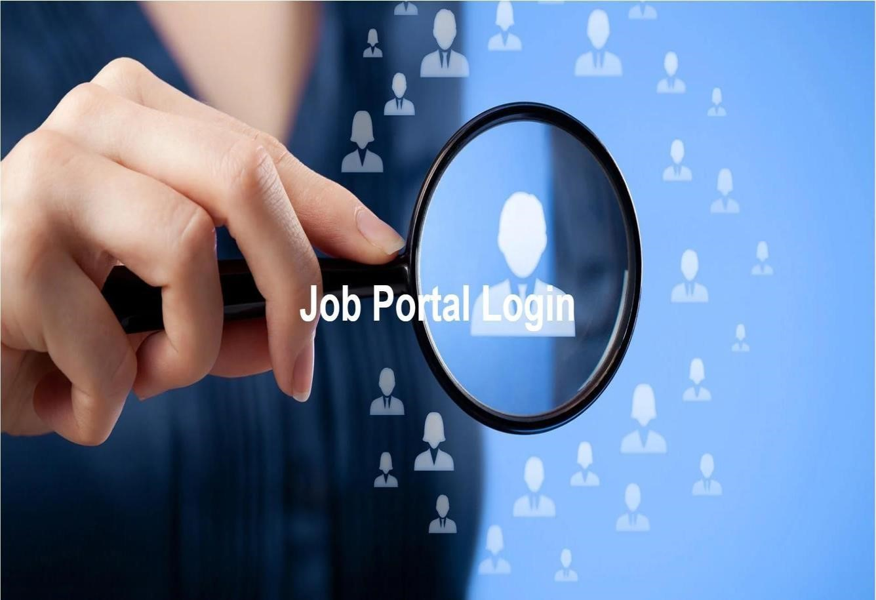



# IMPLEMENTATION

## 4.1 CODE

<!DOCTYPE html>

<html>

<head>

<link rel="stylesheet" href="https://cdnjs.cloudflare.com/ajax/libs/fontawesome/5.15.4/css/all.min.css">

<style>

/* First page styling */

.first-page { background-image: url('https://cdn.wallpapersafari.com/51/27/78VlbA.jpg'); height: 100vh; background-size: cover; background-position: center; display: flex; justifycontent:

center; align-items: center;

}

.heading { color: white; font-size: 60px; text-align:

center; } a { text-decoration: none; color: white; } a:hover { color:

#007BFF; } body { font-family: Arial, Helvetica, sans-serif;

}

/* Full-width input fields */ input[type=text], input[type=password]

{ width: 100%; padding: 12px 20px; margin: 8px 0; display: inline-block; border: 1px solid #ccc; box-sizing: border-box; }

/* Set a style for all buttons */ button { background-color: #04AA6D; color: white; padding: 14px 20px; margin: 8px 0; border: none; cursor: pointer; width:

100%; }

button:hover { opacity: 0.8;

}

/* Extra styles for the cancel button */

.cancelbtn { width: auto; padding: 10px 18px; background-color: #f44336;

}

/* Center the image and position the close button */ .imgcontainer { text-align: center; margin: 24px 0 12px 0;

position: relative; }

img.avatar { width: 40%; border-radius:

50%;

}

.container { padding:

16px; border-radius: 10px; }

span.psw { float: right; padding-top:

16px;

}

/* The Modal (background) */

.modal { display: none; position: fixed; zindex: 1; left: 0; top: 0; width: 100%; height: 100%; overflow: auto; background-color: rgba(0, 0, 0,

0.4); padding-top: 10px;

}

/* Modal Content/Box */

.modal-content { backgroundcolor: #fefefe; margin: 5% auto 15% auto; border: 1px solid #888; width: 80%;

}

/* The Close Button (x) */

.close { position: absolute; right:

25px; top: 0; color:

#000; font-size: 35px; font-weight: bold;

}

.close:hover,

.close:focus { color: red; cursor:

pointer;

}

/* Add Zoom Animation */ .animate { animation: animatezoom 0.6s; }

@keyframes animatezoom

{ from { transform: scale(0); }

to { transform: scale(1);

}

}

/* Responsive styles */

@media screen and (max-width: 300px)

{ span.psw { display: block; float: none;

}

.cancelbtn { width:

100%;

}

}

.homepage,

.jobspage,

.companiespage,

.contactpage

{ height:

100vh; display: none;

}

.homepage {

background-image: url('https://c1.wallpaperflare.com/preview/80/193/318/job-job-offer-

workplace-job-search.jpg'); background-size:

cover;

}

.topnav { overflow: hidden; float: right; padding:

10px;

}

.topnav a { color: #f2f2f2; text-align: center; padding: 14px 16px; text-decoration: none; font-weight: bold;

}

.topnav a:hover { backgroundcolor:

#ddd; color: black;

}

.topnav a.active { backgroundcolor:

#04AA6D; color: white;

}

.jobspage { background-image: url('https://img.freepik.com/premium-vector/jobssearchrecruitment- hiring-employment-find-job-openings-opportunities-career-growth-young-unemployed-man-

usesmagnifying-glass-search-recruitment-illustration_327176-1666.jpg'); background-size: cover; }

.contactpage { backgroundcolor: #ff657d; color: white; padding: 20px; font-family:

Sans-Serif; text-align: center; height: 100%; background-size: cover;

}

.contactpage h2 { font-size:

36px; margin-bottom:

10px;

}

.contactpage p { font-size:

18px; margin: 5px 0;

}

.contactpage form { max-width: 800px; margin: auto; padding:

8px;

}

.contactpage input,

.contactpage textarea

{ width: 100%; margin: 8px 0; padding: 12px; border-radius: 5px; border: 1px solid #ddd; resize: vertical;

}

.contactpage { color: #ffffff; fontweight: bold; font-size:

20px;

}

.email { color: #3376fe; fontweight: bold;

}

/* Search bar styling */

.search-container { margin-top:

20px; width: 100%; maxwidth:

600px; text-align: center;

}

.search-container input[type="text"] { width: 80%; padding: 12px; border-radius: 5px; border: 1px solid #ddd;

}

.search-container .search-button

{ padding: 12px; border-radius: 5px; border: none; backgroundcolor: #04AA6D; color: white; cursor: pointer; width: 50%; margin: 10px;

}

/* Styling for the results below search bar */ .searchresults { margin-top:

20px; text-align: center;

}

.search-results ul { list-styletype:

none; padding: 0;

}

.search-results ul li

{ background-color: #f0f0f0; padding: 10px; border-radius: 5px; margin:

5px 0; font-size: 18px; }

.tenthJobPages { background: linear-gradient(to left, #d8b5ff, #1eae98); padding: 10px; text-align: center; align-items: center; background-size: cover;

}

.twelthJobPages { background: linear-gradient(to left, #d8b5ff, #1eae98); padding: 10px; text-align: center; alignitems: center; background-size: cover;

}

.MBAJobPages {

background: linear-gradient(to left, #d8b5ff, #1eae98); padding: 10px; text-align: center; align-items: center; background-size: cover;

}

.BtechJobPages { background: linear-gradient(to left, #d8b5ff, #1eae98); padding: 10px; text-align: center; align-items: center; background-size: cover;

}

.job-cards { height: cover; width: 95%; backgroundcolor: white; color: black; borderradius: 8px; padding: 10px; margin:

10px; font-weight: bold;

}

.job-cards h3 { font-weight:

800;

}

.job-cards p { text-align: left; margin: 10px; color: #474747;

}

/COMPANY SECTION/ .companiespage { background-color:

white; height: 100vh; padding: 8px; text-align: center; background-size: cover;

}

.companies-grid { display: grid; gridtemplatecolumns: repeat(3, 1fr); gap: 20px; /*

Space between the cards */ padding: 20px;

/* Padding around the grid */

}

.company-card { background-color: #C3C5C6; /* Background color for cards */ border-radius: 10px;

/* Rounded corners */ box-shadow: 0 2px 5px rgba(0, 0, 0, 0.1); /*

Subtle shadow */ text-align: center; /* Center the text and image */ padding: 10px; /* Padding inside the card */ position:

cursor;

}

.company-card img { width: 100%; /* Make images responsive */ height: 80%; /* Maintain aspect ratio */ borderradius: 10px;

/* Rounded corners for images */

}

.company-card h3 { margin-top:

8px;

/* Space above the heading */

}

.workexperience

{ background-color: #ffcad0; height: 100vh; padding: 10px;

}

.applybtn { width: auto; padding: 10px 18px; background-color:

#0BA3DB; border-radius: 8px;

}

.applicationform { background: linear-gradient(to left, #d8b5ff, #1eae98); padding: 10px; text-align: center; alignitems: center; background-size: cover;

}

.checkbox-group { margin-top:

15px;

}

.checkbox-group label { display: block;

margin-bottom: 5px;

}

.modalapplication { display: none; position: fixed; z-index: 1; left: 0; top: 0; width: 100%; height: 100%; overflow: auto; background-color:

rgba(0, 0, 0, 0.4);

}

.modal-contentapplication { background-color: #fefefe; margin: 10% auto; padding: 20px; border:

1px solid #888; width: 80%; max-width: 500px; borderradius: 10px;

}

.summary { display: none; /* Hidden initially */ padding: 15px; border:

1px solid #ccc;

margin-top: 20px;

}

</style>

</head>

<body>

<!-- First page with job portal login link -->

<div id="firstpage" class="first-page">

<h2 class="heading">

<a href="#id01" onclick="document.getElementById('id01').style.display='block'">Job Portal Login</a>

</h2>

</div>

<!-- Second page (login form) -->

<div id="id01" class="modal">

<form class="modal-content animate">

<div class="imgcontainer">

<span onclick="document.getElementById('id01').style.display='none'" class="close"

title="Close Modal">&times;</span>

<img src="https://cdn4.iconfinder.com/data/icons/avatars-21/512/avatar-circlehumanfemale-

5-512.png" alt="Avatar" class="avatar">

</div>

<div class="container">

<label for="uname"><b>Username</b></label>

<input type="text" placeholder="Enter Username" name="uname" required>

<label for="psw"><b>Password</b></label>

<input type="password" placeholder="Enter Password" name="psw" required>

<button type="button" onclick="redirectToHomePage()">Login</button>

<label>

<input type="checkbox" checked="checked" name="remember"> Remember me

</label>

</div>

<div class="container" style="background-color:#f1f1f1">

<button type="button" onclick="document.getElementById('id01').style.display='none'"

class="cancelbtn">Cancel</button>

<span class="psw">Forgot password?</span>

</div>

</form>

</div>

<!-- Home Page with Nav Bars -->

<div id="id02" class="homepage">

<div class="topnav">

<a href="#home" onclick="showSection('id02')">Home</a>

<a href="#jobs" onclick="showSection('jobs')">Jobs</a>

<a href="#companies" onclick="showSection('companies')">Companies</a>

<a href="#contact" onclick="showSection('contact')">Contact</a>

</div>

</div>

<!-- Jobs Page -->

<section id="jobs" class="jobspage">

<div class="search-container">

<input type="text" placeholder="Search for jobs..."> <br/>

Options for the jobs you seraching for

<select name="drop" id="123">

<option id="1" name="op1">10 th</option>

<option id="2" name="op1">12 th</option>

<option id="3" name="op1">MBA</option>

<option id="4" name="op1">B-Tech</option>

</select><br/>

<button class="search-button" onclick="handleSearch()">Search</button>

</div>

<div id="search-results" class="search-results">

<!-- Results will appear here -->

</div>

</section>

<!-- Companies Page -->

<section id="companies" class="companiespage" style="display: none;">

<h1>Top Companies Hiring</h1>

<p>List of Companies Hiring with us!</p>

<div class="companies-grid">

<div class="company-card" id="#company-card1" onclick="showSection('workexperience')">

<img src="https://www.travelinusa.us/wp-content/uploads/sites/3/2017/12/Google-

headquarters-Silicon-Valley.jpg" alt="google">

<h3>Google</h3>

</div>

<div class="company-card" id="#company-card1" onclick="showSection('workexperience')">

<img src="https://www.thestreet.com/.image/t_share/MTkzMTE3MTYzMzI0NzEyNTAx/microsoft_office_ 1_kl_101822.jpg" alt="microsoft">

<h3>Microsoft</h3>

</div>

<div class="company-card" id="#company-card1" onclick="showSection('workexperience')">

<img src="https://www.capitalism.com/wp-

content/uploads/2020/11/Depositphotos_45177201_l-2015.jpg" alt="apple">

<h3>Apple</h3>

</div>

<div class="company-card" id="#company-card1" onclick="showSection('workexperience')">

<img src="https://www.techgenyz.com/wp-content/uploads/2020/09/infosys.jpg"

alt="infosys">

<h3>Infosys</h3>

</div>

<div class="company-card" id="#company-card1" onclick="showSection('workexperience')">

<img

src="https://analyticsindiamag.com/wpcontent/uploads/2021/03/Wipro_AIM1024x768.jpg" alt="wipro">

<h3>Wipro</h3>

</div>

<div class="company-card" id="#company-card1" onclick="showSection('workexperience')">

<img src="https://thumbs.dreamstime.com/z/prague-czech-republic-may-ibm-

companylogoheadquarters-building-116972459.jpg" alt="IBM">

<h3>IBM</h3>

</div>

</div>

</section>

<!-- Contact Page -->

<section id="contact" class="contactpage">

<h2>Get in Touch</h2>

<p>Have a Question or Comment? We'd like to hear from you!</p>

<form id="contactForm" onsubmit="handleContactForm(event)">

<label>Name:</label><input type="text" required>

<br>

<label>Email:</label><input type="email" required>

<br>

<label>Contact:</label><input type="tel" required>

<br>

<label>Message:</label><textarea required></textarea>

<button type="submit">Submit</button>

<p id="successMessage" style="color:#ff3333; display: none;">Thank you for your message! We will get back to you soon.</p>

<p class="email">jobhubportal@gmail.com</p>

<p class="email">9898908973</p>

</form>

</section>

<!--tenthjobspage -->

<section id="tenthJobs" class="tenthJobPages" style="display: none;">

<h2>BY 10th QUALIFICATION JOBS</h2>

<p style="font-weight:bold;">Here are job listings related to 10th Qualification</p>

<div class="job-cards">

<h3>Railway Group D jobs include positions like Track</h3>

<p>Maintainer, Pointsman, and Helper in various departments Eligibility: 10th pass or ITI (Industrial Training Institute) certificate

Age limit: 18-33 years.

<br>

⁃ Selection process: Written test, Physical Efficiency Test (PET), and Document Verification.

<br>

* Pay scale: Level 1 of the 7th CPc Pay Matrix (₹18,000-₹56.900).

</p>

<button class="applybtn" onclick="showSection('applicationform')">Apply</button>

</div>

<div class="job-cards">

<h3>POLICE CONSTABLE</h3>

<p>- Police Constables are entry-level positions in the police force, responsible for maintaining law and order, investigating

crimes, and serving the community.

<br>

* Eligibility: 10th or 12th pass (depending on the state or union territory).

<br>

* Age limit: 18-25 years (rexable for reserved categories).

<br>

⁃ Selection process: Written test, Physical Efficiency Test

(PET), Physical Measurement Test (PMT), and Medical Examinaton.

<br>

* Pay scale: Varies by state or union territory, but typically in the range of ₹21,000-₹69,000.

</p>

<button class="applybtn" onclick="showSection('applicationform')">Apply</button>

</div>

<div class="job-cards">

<h3>POST OFFICE</h3>

<p>- Post Office jobs include positions like Postal Assistant, Sorting Assistant, Postman, Mail Gaurd, and Gramin Dak Sevak (GDS).

<br>

* Eligibility: 10th or 12th pass (depending on the post).

<br>

* Age limit: 18-27 years (rexable for reserved categories).

<br>

⁃ Selection process: Written test, Physical Efficiency Test (PET), and Document Verification.

<br>

* Pay scale: Varies by post, but typically in the range of ₹21,000-₹81,000.

</p>

<button class="applybtn" onclick="showSection('applicationform')">Apply</button>

</div>

</section>

<!-- 12thjobpage -->

<section id="twelthJobs" class="twelthJobPages" style="display: none;">

<h2>BY 12th QUALIFICATION JOBS</h2>

<p>Here are job listings related to 12th Qualification</p>

<div class="job-cards">

<h3>GOVERNMENT CLERK JOBS</h3>

<p>Government Clerk jobs are entry-level positions in various government departments and ministries. Here are some key details:

<br>

* Eligibility: 12th standard (HSC) passed in any stream (Arts, Commerce, Science, etc.).

<br>

* Age limit: 18-27 years (rexable for reserved categories).

<br>

⁃ Selection process: Written test, Interview, and/or Skill test

<br>

* Pay scale: ₹18,000-₹56,000(Level1 of 7th CPC Pay Matrix).

</p>

<button class="applybtn" onclick="showSection('applicationform')">Apply</button>

</div>

<div class="job-cards">

<h3>NATIONAL DEFENCE ACADEMY</h3>

<p>The National Defence Academy (NDA) is a prestigious Institute that trains cadets to become officers in the Indian Armed Forces.

<br>

* Eligibility: 12th standard (HSC) passed/appearing in any stream(Arts, Commerce, Science,

etc).

<br>

* Age limit: 16.5-19.5 years old.

</p>

<button class="applybtn" onclick="showSection('applicationform')">Apply</button>

</div>

<div class="job-cards">

<h3>RAILWAY CLERKS</h3>

<p>Railway Clerks are responsible for managing railway operations, maintaining records, and providing customer service.

<br>

* Eligibility: 12th standard (HSC) passed/appearing in any stream(Arts, Commerce,

Science,

etc).

<br>

* Age limit: 18-27 years (relaxable for reserved categories) </p>

<button class="applybtn" onclick="showSection('applicationform')">Apply</button>

</div>

</section>

<!-- MBAjobspage -->

<section id="MBAjobs" class="MBAJobPages" style="display:none;">

<h2>BY MBA QUALIFICATION JOBS</h2>

<p>Here are job listings related to MBA Qualification</p>

<div class="job-cards">

<h3>MANAGEMENT CONSULTANT</h3>

<p>Industry: Consulting, Finance, Healthcare, IT, Manufacturing, Government, Non-profit, Retail, Hospitality, Energy

<br>

Work Experience:

<br>

2-5 years (entry-level), 5-10 years (senior-level), 10+ years (executive level) <br>

Education:

<br>

* MBA (Master of Business Administration)

<br>

* Bachelor's Degree in a related field (e.g., Business, Management, Economics)

<br>

-Professional Certifications (e.g., CMC - Certified Management Consultant)

<br>

Salary Range (India):

<br>

-Entry-level: ₹500,000 - ₹800,000 per annum

<br>

-Senior-level: ₹1,000,000 - ₹2,000,000 per annum

<br>

-Executive-level: ₹2,500,000 - ₹5,000,000 per annum

</p>

<button class="applybtn" onclick="showSection('applicationform')">Apply</button>

</div>

<div class="job-cards">

<h3>MARKETING MANAGER</h3>

<p>Industry: FMCG, Retail, E-commerce, Healthcare, Finance, Technology, Automotive

<br>

Work Experience:

<br>

5-8 years (entry-level), 8-12 years (senior-level), 12+ years (executive level)

<br>

Education:

<br>

* MBA (Master of Business Administration)

<br>

* Bachelor's Degree in a related field (e.g., Business, Communications)

<br>

Salary Range (India):

<br>

-Entry-level: ₹600,000 - ₹1,000,000 per annum

<br>

-Senior-level: ₹1,200,000 - ₹2,500,000 per annum

<br>

-Executive-level: ₹3,000,000 - ₹6,000,000 per annum

</p>

<button class="applybtn" onclick="showSection('applicationform')">Apply</button> </div>

<div class="job-cards">

<h3>IT MANAGER</h3>

<p>Industry: All industries, including Finance, Healthcare, Retail, IT, Manufacturing, Government

<br>

Work Experience:

<br>

5-10 years (entry-level), 10-15 years (senior-level), 15+ years (executive level) <br>

Education:

<br>

* Bachelor's Degree in Computer Science, Information Technology, or related field <br>
* Master's Degree in IT Management, Business Administration, or related field (preferred)

<br>

Salary Range (India):

<br>

-Entry-level: ₹800,000 - ₹1,200,000 per annum

<br>

-Senior-level: ₹1,500,000 - ₹2,500,000 per annum

<br>

-Executive-level: ₹3,000,000 - ₹6,000,000 per annum

</p>

<button class="applybtn" onclick="showSection('applicationform')">Apply</button>

</div>

</section>

<!-- BTECHjobspage -->

<section id="Btechjobs" class="BtechJobPages" style="display: none;">

<h2>BY B-Tech QUALIFICATION JOBS</h2>

<p>Here are job listings related to B-Tech Qualification</p>

<div class="job-cards">

<h3>BUSINESS ANALYTICS</h3>

<p>Business Analysts work in various industries, including: (Finance and Banking, Healthcare, Technology, Retail, Manufacturing, Government, Consulting) <br> Work Experience:

<br>

5-10 years (entry-level), 10-15 years (senior-level), 15+ years (executive level)

<br>

QUALIFICATIONS:

<br>

1. A Bachelor's Degree in related field (e.g., business, computer science, information

systems)

<br>

1. Professional certificattons (e.g., CHAP, CCHA, ITIL)

<br>

1. An MBA or master's degree in a related field (oprianat) <br>

SALARY RANGE:

<br>

1. Entry-evel (0-3 vears): ₹400,000 - 7700;000 per annum

<br>

1. Mid-level (4-7 years): ₹800,000- ₹1,200,000 per annum annum

<br>

1. Senior-level (8-12 years): ₹1,500,000 - ₹2,500,ooo per annum

<br>

1. Lead/Manager-level (13+ years): ₹2,500,000 - ₹5,000,000 per annum

</p>

<button class="applybtn" onclick="showSection('applicationform')">Apply</button>

</div>

<div class="job-cards">

<h3>SOFTWARE DEVELOPER</h3>

<p>

A Seftware Developer is a professional who designs , creates, tests,and maintains software applications <br>

QUALIFICATIONS:

<br>

1. A bachelor's degree in Computer Science, Information

Technologv, or related field

<br>

2.Professional certifications (e.g., AWS Ceriffed Developer.

Certified Scrum Master)

<br>

3. A master's degree in Computer Srience or related field

(optional)

<br>

SALARY RANGE:

<br>

1 Entry-level (0-3 years): ₹400,000 - ₹700,000 per annum

<br>

2.Mid-level (4-7 years): ₹800,000 - ₹1,000,000 per annum

</p>

<button class="applybtn" onclick="showSection('applicationform')">Apply</button>

</div>

<div class="job-cards">

<h3>WEB DEVELOPMENT</h3>

<p>Web development is the process af beuilding and maintaining websites, web applications, and mobile applications.

<br>

Web developers work in various industries, including:

(Technology ,E-commerce, Healthcure, Finance, Education

Government, Non-profit)

<br>

QUALIFICATIONS:

<br>

1. A bachelor's degree in Computer Science, Information

Technology, or related field

<br>

1. Professional certifications (e.g, Certified Web Developer

Full Stack Developer)

<br>

1. A portfolio of personal er professional web development prejects

<br>

SALARY RANGE:

<br>

1. Entry-level (0-3 years): ₹400,000 - ₹700,000 per annum

<br>

1. Mid-level (4-7 years): ₹800,000 - ₹1,200,000 per annum

<br>

1. Senior-level (8-12 years): ₹1,500,000 - ₹2,500,000 per annum

<br>

1. Lead/Manager-level (13+ years): ₹2,500,000- ₹3,500,000 per annum </p>

<button class="applybtn" onclick="showSection('applicationform')">Apply</button>

</div>

</section>

<section id="workexperience" class="workexperience" style="display:none;">

<h1 style="color:red; font-weight:800;">WORK ENVIRONMENT:</h1>

<P style="font-weight:bold;">Many employees highlight the positive work environment and the company's focus on employee feedback and growth. However, some reviews mention challenges with management and job security

</P>

<h1 style="color:red; font-weight:800;">SALARY:</h1>

<p style="font-weight:bold;">• Average Salary: The average salary at Microsoft varies by role and experience. For instance, software engineer swith 1-9 years of experience earn around ₹31.8 lakhs per year, while senior software engineers with 4-18 years of experience can earn up to ₹53 lakhs per year1.

<br>

• Benefits: Microsoft provides comprehensive benefits, including health insurance, retirement plans, and employee wellness programs

</p>

</section>

<section id="applicationform" class="applicationform" style="display:none;">

<form class="modal-contentapplication animate" onsubmit="submitApplication(event)" id="myform">

<div class="imgcontainer">

<span onclick="closeApplicationForm('applicationform')" class="close" title="Close Modal">&times;</span>

<h2>Job Application Form</h2>

</div>

<div class="container">

<label for="name"><b>Full Name:</b></label>

<input type="text" placeholder="Enter Your Name" id="name" name="name" required>

<label for="email"><b>Email:</b></label>

<input type="text" placeholder="Enter Your Email" id="email" name="email" required>

<label for="phonenumber"><b>Phone Number:</b></label>

<input type="text" placeholder="Enter Your Qualification" id="phonenumber"

name="qualification" required>

<label for="linkedin"><b>Linkedin Profile:</b></label>

<input type="text" placeholder="Enter linkedin profile url" id="linkedin" name="linkedin"

required>

<label for="experience"><b>Experience:</b></label>

<input type="text" placeholder="Enter Your Experience" id="experience"

name="experience" required>

<div class="checkbox-group">

<label><b>Positions</b></label>

<label>

<input type="checkbox" name="Positions" value="Developer"> Developer

</label>

<label>

<input type="checkbox" name="Positions" value="Designer"> Designer

</label>

<label>

<input type="checkbox" name="Positions" value="Manager"> Manager

</label>

</div>

<label for="resume"><b>Upload Resume</b></label>

<input type="file" id="resume" accept=".pdf, .doc, .docx" optional>

<br>

<label for="coverletter"><b>Cover Letter</b></label>

<textarea type="textarea" id="coverletter" name="coverletter"></textarea>

<button type="submit">Submit </button>

<button type="button" onclick="closeApplicationForm('applicationform')"

class="cancelbtn">Cancel</button>

</div>

</form>

</section>

<section id="applicationSummary" class="summary" style="display:none;">

<h2>Application Submitted Successfully</h2>

<p><b>Name:</b> <span id="summaryName"></span></p>

<p><b>Email:</b> <span id="summaryEmail"></span></p>

<p><b>Phone Number:</b> <span id="summaryPhonenumber"></span></p>

<p><b>Linkedin Profile:</b> <span id="summaryLinkedin"></span></p>

<p><b>Experience:</b> <span id="summaryExperience"></span></p>

<p><b>Positions:</b> <span id="summaryPositions"></span></p>

<p><b>Resume:</b> <span id="summaryResume"></span></p>

<p><b>Cover Letter:</b> <span id="summaryCoverletter"></span></p>

</section>

<script>

// Function to display the home page after login function redirectToHomePage()

{ document.getElementById('firstpage').style.display = "none"; document.getElementById('id01').style.display = "none"; document.getElementById('id02').style.display = "block";

}

// Function to show a specific section let previousSectionId = null;

function showSection(sectionId) {

// Save the current visible section before showing the new one

previousSectionId = document.querySelector('section:not([style*="display: none"])')?.id; // Hide all sections document.querySelectorAll('.homepage, .jobspage, .companiespage,

.contactpage, .searchJob

P

ages, .workexperience, .applicationform, .tenthJobPages, .twelthJobPages, .MBAJobPages, .BtechJob Pages').forEach(section => {

section.style.display = "none";

});

// Show the selected section document.getElementById(sectionId).style.display = "block";

}

// Function to handle search function handleSearch() { const searchInput = document.querySelector('.search-container input[type="text"]').value;

// Check if the input is "10th" if (searchInput === "10th")

{ showSection('tenthJobs');

} else if (searchInput === "12th") { showSection('twelthJobs');

} else if (searchInput.toLowerCase() === "mba") { showSection('MBAjobs');

} else if (["btech", "BTECH"].includes(searchInput.toLowerCase()))

{ showSection('Btechjobs');

} else { alert("No results found for '" + searchInput

+ "'"); } } document.addEventListener('keydown', function(event)

{ if (event.key === 'Escape') {

// Check if the "tenthJobs" section is currently visible if

(document.getElementById('tenthJobs').style.display === "block") { redirectToHomePage(); // Go to home page if "tenthJobs" is open

} else { closeApplicationForm(); // Otherwise, close application form or other sections

}

}

});

// Function to handle contact form submission function handleContactForm(event) { event.preventDefault(); // Prevent the default form submission

document.getElementById('successMessage').style.display = 'block'; // Show success message document.getElementById('contactForm').reset(); // Reset the form fields

}

// Function to close the application form and return to the previous section function closeApplicationForm() { if (previousSectionId)

{ showSection(previousSectionId); // Return to the previous section previousSectionId = null; // Reset the previous section ID

} else { console.error("Previous section not found."); } } function submitApplication(event) { event.preventDefault(); // Prevent form from actually submitting

// Capture form values

const name = document.getElementById('name').value; const email = document.getElementById('email').value; const phonenumber = document.getElementById('phonenumber').value; const linkedin = document.getElementById('linkedin').value; const experience = document.getElementById('experience').value;

// Capture selected positions (checkbox values) const positions =

Array.from(document.querySelectorAll('input[name="Positions"]:checked')).map(position => position.value);

// Handle resume file (check if a file is selected) const resumeInput = document.getElementById('resume'); const resumeFile = resumeInput.files[0]; const resumeName = resumeFile ? resumeFile.name : 'No file uploaded'; // Handle no file

selected

const coverletter = document.getElementById('coverletter').value;

// Populate the summary with form values

document.getElementById('summaryName').innerText = name; document.getElementById('summaryEmail').innerText = email; document.getElementById('summaryPhonenumber').innerText = phonenumber; document.getElementById('summaryLinkedin').innerText = linkedin; document.getElementById('summaryExperience').innerText = experience; document.getElementById('summaryPositions').innerText = positions.join(', '); document.getElementById('summaryResume').innerText = resumeName; document.getElementById('summaryCoverletter').innerText = coverletter;

// Hide the form and show the summary

document.getElementById('applicationform').style.display = 'none';

document.getElementById('applicationSummary').style.display = 'block';

}

</script>

</body>

</html>

# RESULT SCREENS



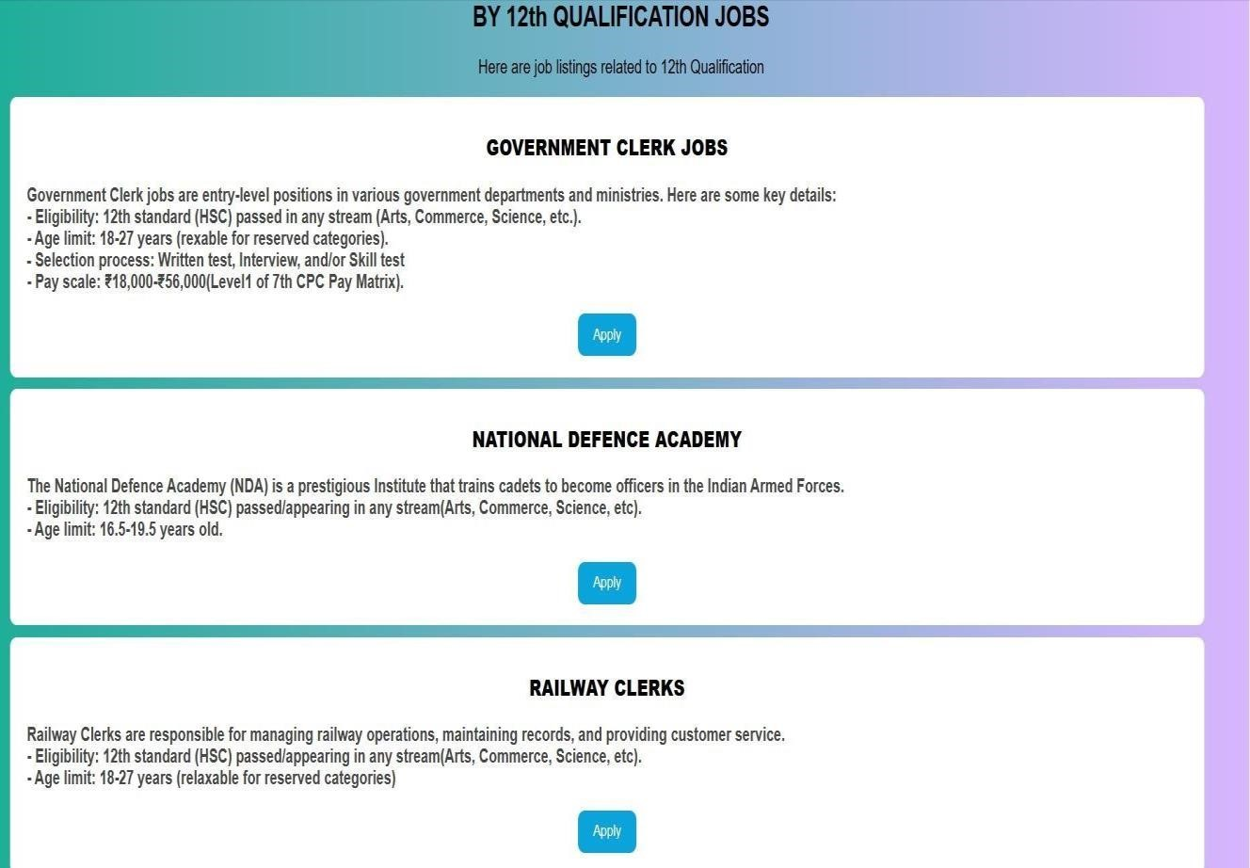



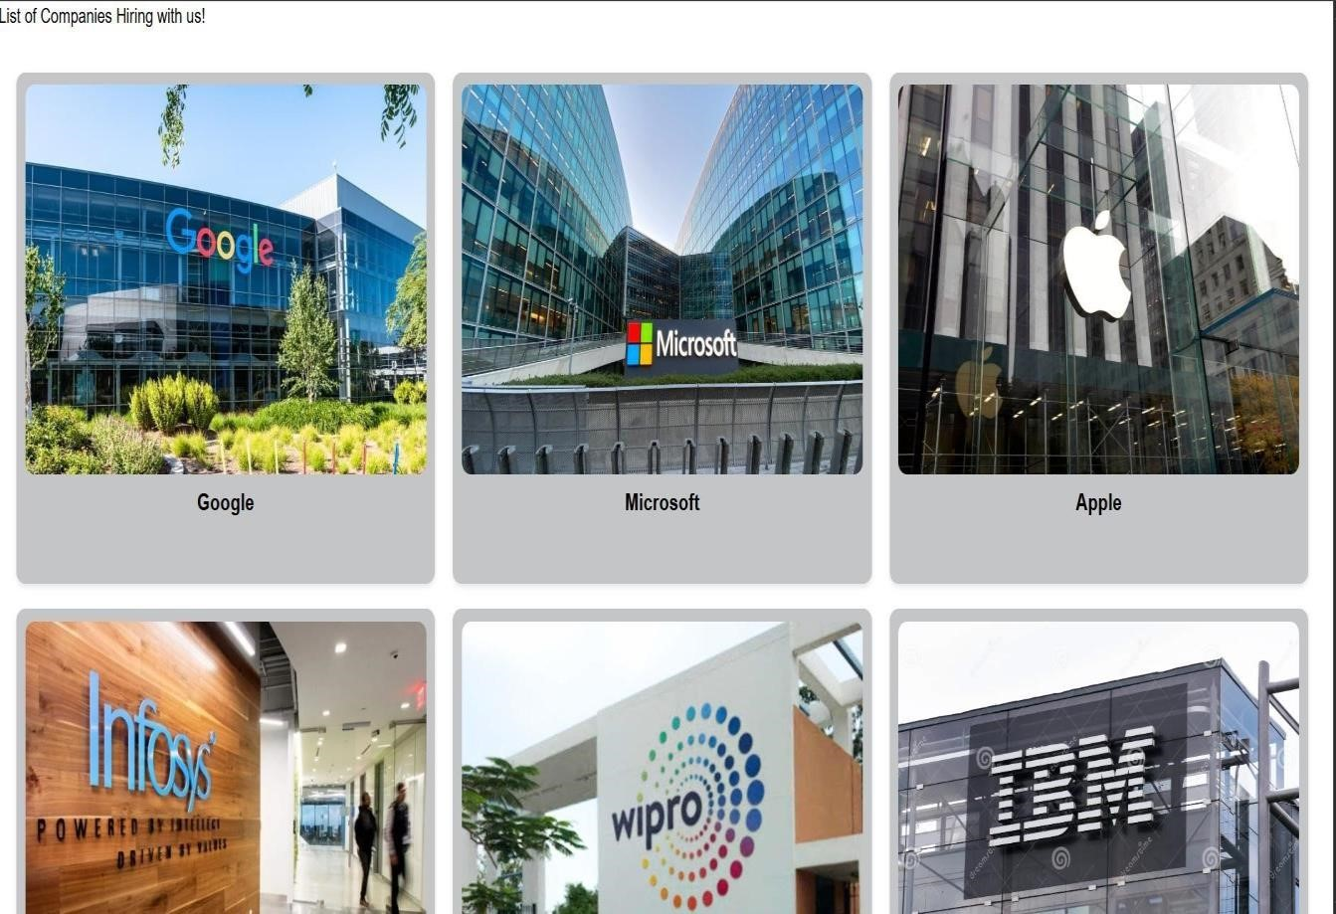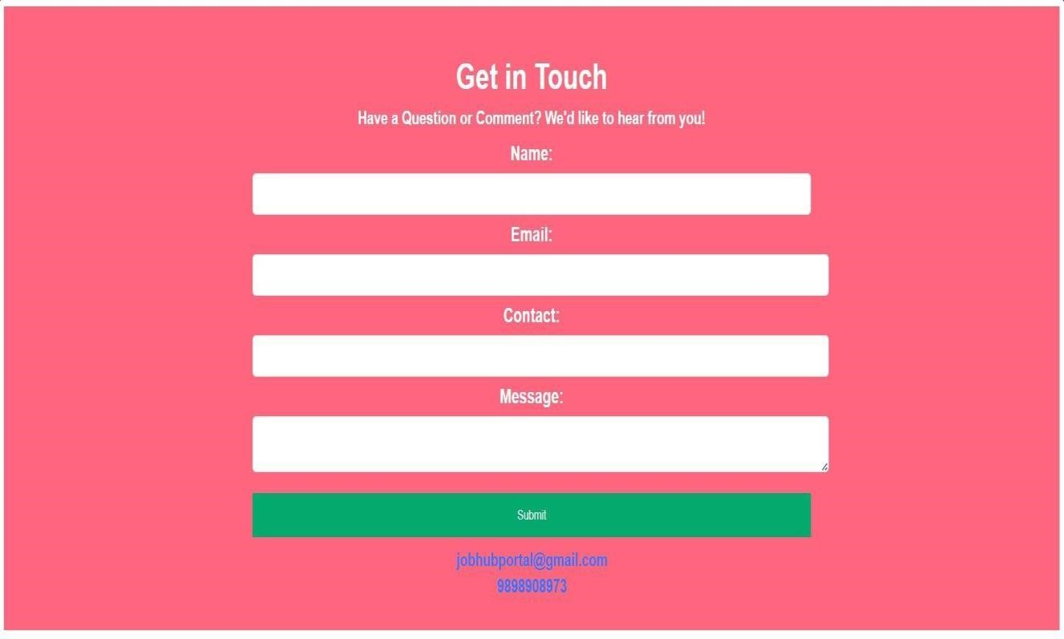

# CONCLUSION

The Job Portal project successfully bridges the gap between job seekers and employers by providing a user-friendly and efficient platform that simplifies and enhances the job search and recruitment processes. Leveraging modern technology, the portal offers intuitive navigation, advanced search functionality, and real-time notifications, ensuring a seamless and engaging user experience.

The implementation of intelligent algorithms has significantly improved job-candidate matching, reducing the time and effort required to find suitable positions and candidates, leading to higher placement rates and better-fit hires. Employers benefit from a streamlined process for posting job listings, managing applications, and communicating with candidates, enabling quicker and more effective hiring decisions.

The inclusion of resume builders, application tracking systems, and career development resources equips job seekers with the necessary tools to enhance their employability and navigate the job market successfully. The project also prioritizes data security, ensuring that user information is protected, thereby building trust and reliability among users.

The platform is designed to be scalable, accommodating an increasing number of users and job posts without compromising performance, and adaptable to future technological advancements and user needs. Providing users with insights into job market trends, salary ranges, and industry information empowers both job seekers and employers to make informed decisions, further enhancing the overall effectiveness of the platform.

Mobile compatibility ensures that users can access job listings and manage applications on-the-go, making the platform more convenient and accessible. The Job Portal project lays a solid foundation for continuous improvement and innovation, with potential for integrating more advanced features such as AI-driven career coaching, automated interview scheduling, and real-time market analytics.

This comprehensive approach ensures that the Job Portal project not only meets the current demands of the job market but also positions itself as a forward-thinking solution that can adapt and grow with the evolving needs of its users.